------

sample1

------

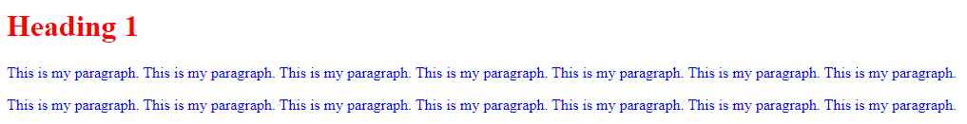

------

Sample2

------

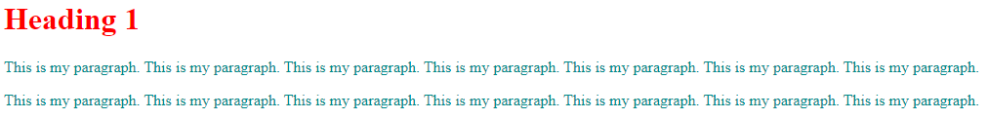

------

Sample3

------

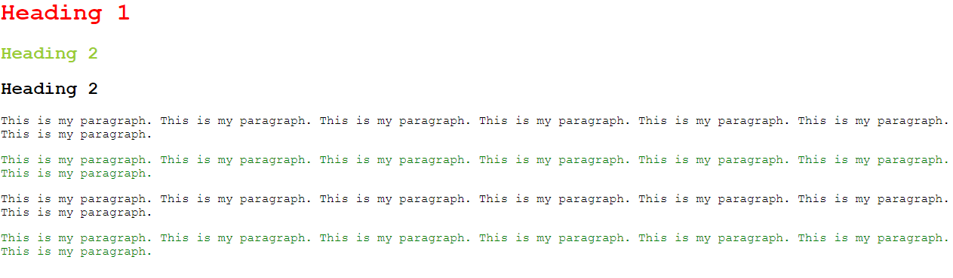

------

Sample4

------

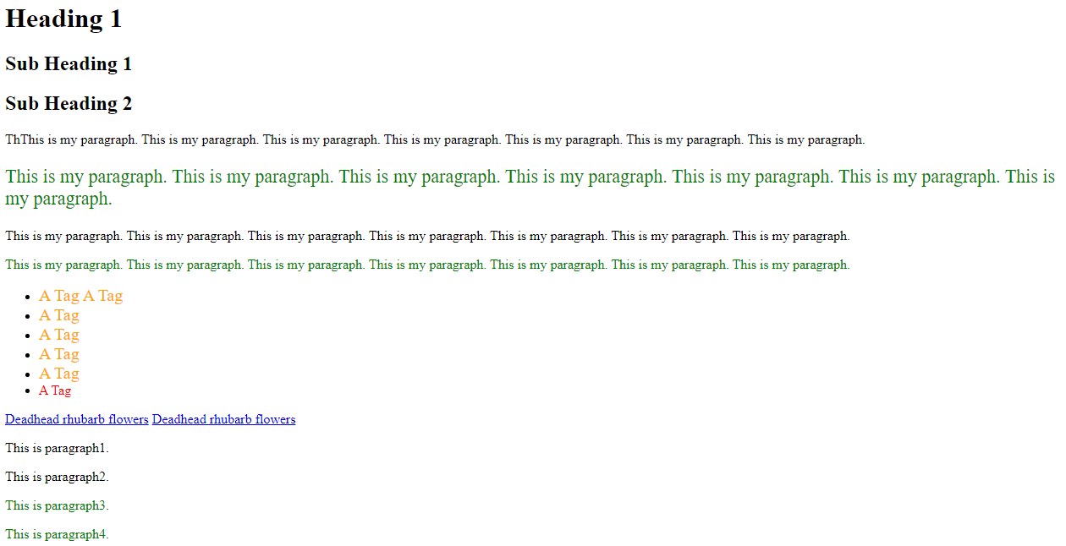

------

Sample5

------

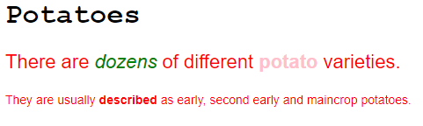

------

Sample6

------

